
For more information:
Sarah Wynn Benton
BRAVE Public Relations
404.233.3993
sbenton@emailbrave.com

FOR IMMEDIATE RELEASE

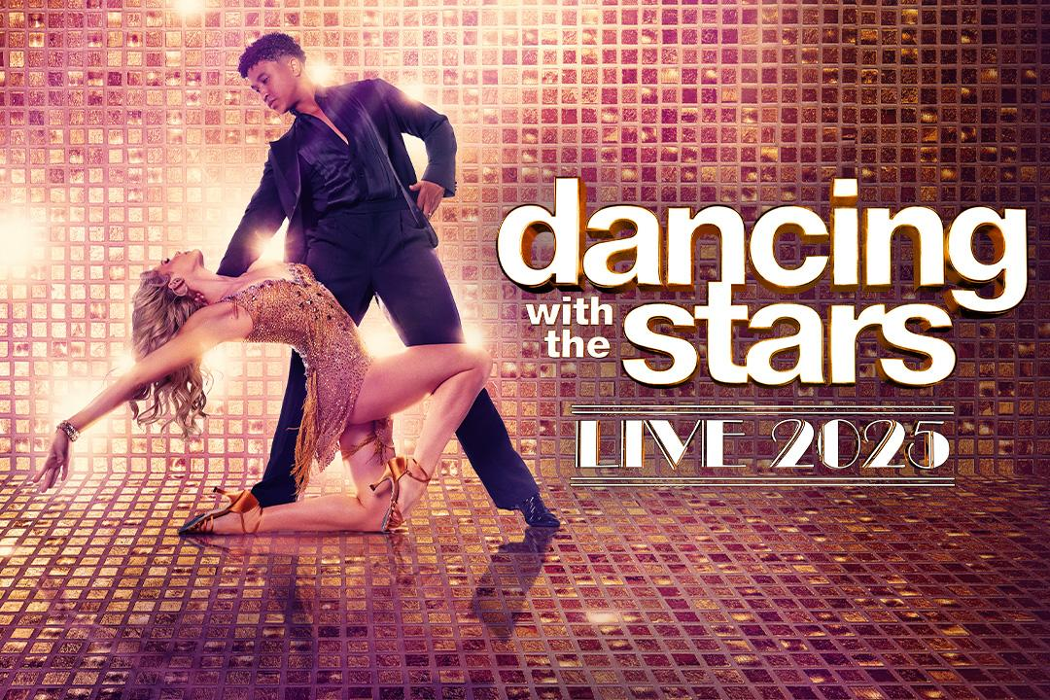

“Dancing With The Stars: Live!” Returns with a Spectacular Brand-New Show
This Winter at the Fox Theatre, Feb. 21
Starring “Dancing with the Stars” Professional Dancers:
Emma Slater, Alan Bersten, Brandon Armstrong, Britt Stewart, Daniella Karagach,
Gleb Savchenko, Pasha Pashkov and Rylee Arnold.
Plus, celebrity guest stars to be announced!

Download tour art and dates HERE | Download tour video HERE | Watch the tour announcement HERE

Tickets on sale this Friday 10/11!
Mirrorball Member Presale for tickets & VIP Packages starts this Wednesday 10/9 at 10 a.m. local time.
For more info and to sign up for this FREE membership, go to DWTSTour.com

ATLANTA (Oct. 8, 2024) – Following last year’s fan-frenzy that led to a sensational sold-out tour, “Dancing with the Stars” is back on tour to heat up the winter with a dazzling, sexy, high energy, brand-new live production! Launching Jan. 7 at Altria Theater in Richmond, Virginia, and making a stop at Atlanta’s Fox Theatre, this year’s all-new stage show will feature your favorite professional dancers from the hit television series performing glittering new numbers as well as some of the showstoppers featured in season 33. To purchase tickets and to get the full list of tour dates, please visit dwtstour.com.

Audiences at “Dancing with the Stars: Live!” will have the opportunity to experience the breathless excitement, the athleticism and the artistry they see in the TV show’s famed ballroom live, up-close and personal. The tour delivers an unforgettable night of electrifying dance performances from world-renowned dancers who topped the leaderboard, including Emma Slater, Alan Bersten, Brandon Armstrong, Britt Stewart, Daniella Karagach, Gleb Savchenko, Pasha Pashkov and Rylee Arnold.

“It is such an honor to be able to produce the DWTS live tour once again and get to collaborate with the sensational pro dancers, celebs and creative team to bring this show to life. We love getting to see fans of all ages fill the venues and get to experience all the excitement that DWTS has to offer. We at faculty promise to deliver a brand-new next level show in 2025 that is sure to bring the ballroom to life in the fan’s hometown.” – Jared Paul, Faculty Inc.

“Dancing with the Stars: Live!” is also thrilled to announce that Emmy Award winner Mandy Moore (Taylor Swift’s The Eras Tour, La La Land) will be returning to choreograph and direct this year’s tour. “Directing this tour is one of my favorite times of the year. I have a long-standing history with the DWTS brand and these dancers, it’s like returning home to family. The collaboration with these world class performers presents an amazing opportunity to highlight their inimitable talent, their athleticism, and it’s what truly makes them artists.” – Mandy Moore

“Dancing with the Stars” is massively popular with millions of fans watching our TV show each week, yet so few are able to come to Hollywood and secure a coveted seat in our live studio audience. With the DWTS Tour, we’re thrilled to unlock a rare and unique opportunity for our fans to experience live and in-person the magic they see each week on TV. Watching the TV show is brilliant, but when you see gravity-defying feats right in front of you and feel the exhilaration of some of the most powerful performances ever seen on the dancefloor, it’s a whole new phenomenon,” – Ryan O’Dowd, Executive Vice President of Entertainment & Music at BBC Studios Los Angeles Productions and BBC Studios Executive Producer for Dancing with the Stars.

Tickets for “Dancing with the Stars: Live!” go on sale to the public on Friday, Oct. 11 at 10 a.m. local time at DWTSTour.com.

Fans who want first access to the best seats and VIP, can sign up for a Mirrorball Membership – this membership is FREE To Join and includes exclusive presale, news updates, a sneak peek of the tour and more! Head to DWTSTour.com to sign up now. VIP packages will be available and include Premium Tickets, Meet & Greet Photo Opportunity, interactive experience with members of the DWTS touring cast, Exclusive Merchandise and more. Details and info at dwtstour.com.

“Dancing with the Stars: Live!” is produced by Faculty Productions in association with BBC Studios Los Angeles Productions and is promoted by Live Nation and NS2.
“Dancing with the Stars: Live!” Dates:

Jan. 7 – Richmond, VA – Altria Theater
Jan. 9 – Baltimore, MD – Lyric Baltimore
Jan. 10 – Uncasville, CT – Mohegan Sun Arena^
Jan. 11 – Uncasville, CT – Mohegan Sun Arena^
Jan. 12 – Morristown, NJ – Mayo Performing Arts Center^ (2 shows)
Jan. 14 – Portland, ME – Merrill Auditorium at City Hall
Jan. 15 – Manchester, NH – SNHU Arena
Jan. 16 – Boston, MA – Boch Center Wang Theatre
Jan. 18 – Atlantic City, NJ – Borgata Hotel Casino & Spa^
Jan. 19 – Lancaster, PA – American Music Theatre^ (2 shows)
Jan. 21 – Buffalo, NY – Shea’s Buffalo Theatre
Jan. 22 – Schenectady, NY – Proctors
Jan. 23 – University Park, PA – Bryce Jordan Center
Jan. 24 – National Harbor, MD – The Theater at MGM National Harbor
Jan. 25 – Bethlehem, PA – The Wind Creek Event Center^ (2 shows)
Jan. 26 – Philadelphia, PA – The Met Philadelphia presented by Highmark
Jan. 28 – New Brunswick, NJ – State Theatre New Jersey^
Jan. 29 – Brookville, NY – Tilles Center for the Performing Arts
Jan. 30 – White Plains, NY – The Westchester County Center
Jan. 31 – Kitchener, ON – Centre in the Square^
Feb. 1 – Rama, ON – Casino Rama Resort – Entertainment Centre^
Feb. 2 – Verona, NY – Turning Stone Resort & Casino^
Feb. 4 – Pittsburgh, PA – Benedum Center for the Performing Arts
Feb. 5 – Akron, OH – Akron Civic Theatre
Feb. 6 – Detroit, MI – FOX Theatre
Feb. 7 – Columbus, OH – Mershon Auditorium
Feb. 8 – Rosemont, IL – Rosemont Theatre
Feb. 11 – Indianapolis, IN – Murat Theatre at Old National Centre
Feb. 12 – Milwaukee, WI – Miller High Life Theatre
Feb. 13 – Ames, IA – Stephens Auditorium
Feb. 14 – Minneapolis, MN – Northrop
Feb. 15 – Madison, WI – The Orpheum Theater
Feb. 16 – Grand Rapids, MI– DeVos Performance Hall
Feb. 18 – St. Louis, MO – Stifel Theatre
Feb. 19 – Cincinnati, OH – The Andrew J Brady Music Center
Feb. 20 – Nashville, TN – Grand Ole Opry House
Feb. 21 – Atlanta, GA – The Fox Theatre
Feb. 22 – Charlotte, NC – Ovens Auditorium
Feb. 23 – Durham, NC – Durham Performing Arts Center
Feb. 25 – Greensboro, NC – Steven Tanger Center for the Performing Arts
Feb. 26 – Spartanburg, SC – Spartanburg Memorial Auditorium
Feb. 27 – Jacksonville, FL – Moran Theater**
Feb. 28 – Hollywood, FL – Hard Rock Live at Seminole Hard Rock Hotel & Casino Hollywood^**
March 1 – Clearwater, FL – Ruth Eckerd Hall**
March 2 – Orlando, FL – Dr. Phillips Center for the Performing Arts**
March 4 – North Charleston, SC – North Charleston Performing Arts Center
March 5 – Huntsville, AL – Von Braun Center - Mark C. Smith Concert Hall
March 6 – Memphis, TN – Orpheum Theatre
March 7 – Biloxi, MS – Beau Rivage Theatre^
March 8 – Biloxi, MS – Beau Rivage Theatre^
March 9 – Sugar Land, TX – Smart Financial Centre at Sugar Land
March 11 – Grand Prairie, TX – Texas Trust CU Theatre
March 12 – Austin, TX – Bass Concert Hall
March 13 – San Antonio, TX – Majestic Theatre
March 14 – Durant, OK – Choctaw Casino & Resort^
March 15 – Wichita, KS – INTRUST Bank Arena
March 16 – Denver, CO – Buell Theatre
March 18 – Boise, ID – Morrison Center For The Performing Arts
March 19 – Seattle, WA – Paramount Theatre
March 20 – Spokane, WA – First Interstate Center for the Arts
March 21 – Portland, OR – Arlene Schnitzer Concert Hall
March 22 – Redding, CA – Redding Civic Auditorium
March 23 – Santa Rosa, CA – Luther Burbank Center for the Arts
March 25 – San Jose, CA – San Jose Center for the Performing Arts
March 27 – Salt Lake City, UT – Eccles Theater
March 29 – Las Vegas, NV – The Smith Center for the Performing Arts
March 30 – Temecula, CA – Pechanga Resort Casino^ (2 shows)
April 2 – Phoenix, AZ – Arizona Financial Theatre
April 3 – Santa Barbara, CA – Arlington Theatre
April 4 – Indio, CA – Fantasy Springs Resort Casino^
April 5 – Los Angeles, CA – Dolby Theatre

^Not A Live Nation Date
**Tickets for the Clearwater, Orlando, Jacksonville and Hollywood, Florida shows will go on sale at a later date. Follow @dwtstourofficial or go to dwtstour.com for ticket on sale updates for these shows.
*Cast subject to change.

“Dancing with the Stars” airs live Tuesday nights (8 p.m. ET / 5 p.m. PT) on ABC, Disney+ and is available to stream the next day on Hulu

About Faculty Productions:
Faculty, formed by veteran manager and producer Jared Paul in partnership with Live Nation, the world’s leading live entertainment company, produces and creates world-class live branded entertainment and concerts. Faculty is responsible for some of the most successful global touring productions including the Faculty-managed New Kids on the Block recently completed 46-city Magic Summer 2024 Tour, which sold over 500,000 tickets, and the upcoming multi-year Las Vegas Residency: The Right Stuff, set to open in June 2025; and the Big Time Rush 2023 Can’t Get Enough Tour and 2024’s sold-out EU/UK and Australia/Asia Tours. Big Time Rush returned in 2022 after 9 years with sold out shows in the US and Mexico including stops at legendary venues such as Madison Square Garden. In 2022, Faculty produced the first-ever CHEER LIVEtour with stars from the Netflix series, are the long-time producers of the Dancing with the Stars: Live! Tour, and producers of Move Live on Tour (Derek Hough and Julianne Hough), Glee Live! In Concert!, America’s Got Talent Live!, American Idol Live!, and So You Think You Can Dance Live Tour. In 2017, Faculty and Paul created the acclaimed immersive pop-up art exhibit HAPPY PLACE, which started in Los Angeles before moving to locations across the US and Canada and most recently to Sydney, Australia and New Zealand. In 2023-2024, Faculty produced COCOMELON PARTY TIME an all-new, first-of-its-kind, kid-centric event centering on JJ, Cody & friends from the hugely popular children’s program CoComelon, the #2 most subscribed YouTube channel in the world with over 400 million views per month. Party Time has visited 28 cities thus far across the US and Canada entertaining thousands of families.

About BBC Studios
The main commercial arm of BBC Commercial Ltd, BBC Studios generated revenues in the last year of £1.8 billion and a third consecutive year of profits of over £200 million. Able to take an idea seamlessly from thought to screen and beyond, the business is built on two operating areas: the Content Studio, which produces, invests and distributes content globally and Media & Streaming, with BBC branded channels, services including bbc.com and BritBox International and joint ventures in the UK and internationally. The business made more than 2,800 hours of award-winning British programmes last year for a wide selection of public service and commercial broadcasters and platforms, both in the UK and across the globe. Its content is internationally recognised across a broad range of genres and specialisms, and includes world-famous brands like Strictly Come Dancing/Dancing with the Stars, the Planet series, Bluey and Doctor Who.

In the U.S, BBC Studios operates both a distribution business and one of its major production units. The production unit, based in Los Angeles, creates and produces adaptations of UK programs, as well as all new original programs, for linear and digital platforms in the U.S. This production unit is responsible for the phenomenally successful, Emmy®-winning Dancing with the Stars, the multi-award-winning Life Below Zero franchise, the popular reboot of the classic quiz show Weakest Link, the US version of the global sensation The 1% Club, the revved up Top Gear America, and the survival competition series Outlast. In scripted, the team has achieved success adapting British hits, including Ghosts, Call Me Kat (based on the UK format Miranda) and Welcome to Flatch (This Country in the UK) for top U.S. broadcast networks.

BBC Studios | Website | Press Office | Twitter | LinkedIn | Instagram

To apply for media credentials to Live Nation promoted shows:
livenation.com/pressrequests
About the Fox Theatre
The Fox Theatre is one of Atlanta's premier venues for live entertainment, welcoming more than 200 performances a year in its 4,665-seat theatre. From concerts to ballets, comedy, and movies, the historic venue attracts more than 500,000 visitors annually. The theatre hosts over 100 annual private events like wedding receptions, trade shows, corporate meetings, and association functions in two fabulous ballrooms. The Fox’s premium Marquee Club, presented by Lexus, is a 10,000 sq. ft, three-story luxury bar accessible to all Club Level ticket holders or annual members of the Fox Theatre. As a 501(c)(3) nonprofit arts organization, the Fox Theatre is a fiercely protected landmark and nationally acclaimed theatre today. The Fox Theatre proudly acknowledges its partners' generous support: Coca-Cola, Georgia Natural Gas, Georgian Terrace Hotel & Livingston Restaurant, Humana, Lexus, Northside Hospital, and Regions Bank. Tickets for all events are available at FoxTheatre.org, or toll-free at 855-285-8499. Stay connected by following the Fox Theatre on social via @theFoxTheatre on Instagram, Twitter, and Facebook.
Notable accolades include 2023 Billboard Magazine #2 Highest Grossing Theatre Worldwide (5,000 seats or less); 2023 VenuesNow Magazine #2 Year-End Top Stops (2,001-5,000 seats); 2022 IEBA Theatre of the Year; 2021 Billboard Magazine #1 Highest Grossing Theatre Worldwide (5,000 seats or less); 2021 Pollstar Magazine #2 Theatre Worldwide in Ticket Sales and 2021 VenuesNow Magazine #2 Year-End Top Stops (2,001-5,000 seats). Additionally, in 2019, the Fox Theatre was honored with the VenuesNow #1 Top Stop of the Decade Award for Tickets Sold, further cementing its reputation as a premier entertainment venue.

